**Exercise 1: Create a Spring Web Project using Maven**   
  
Task 1 - Build the project

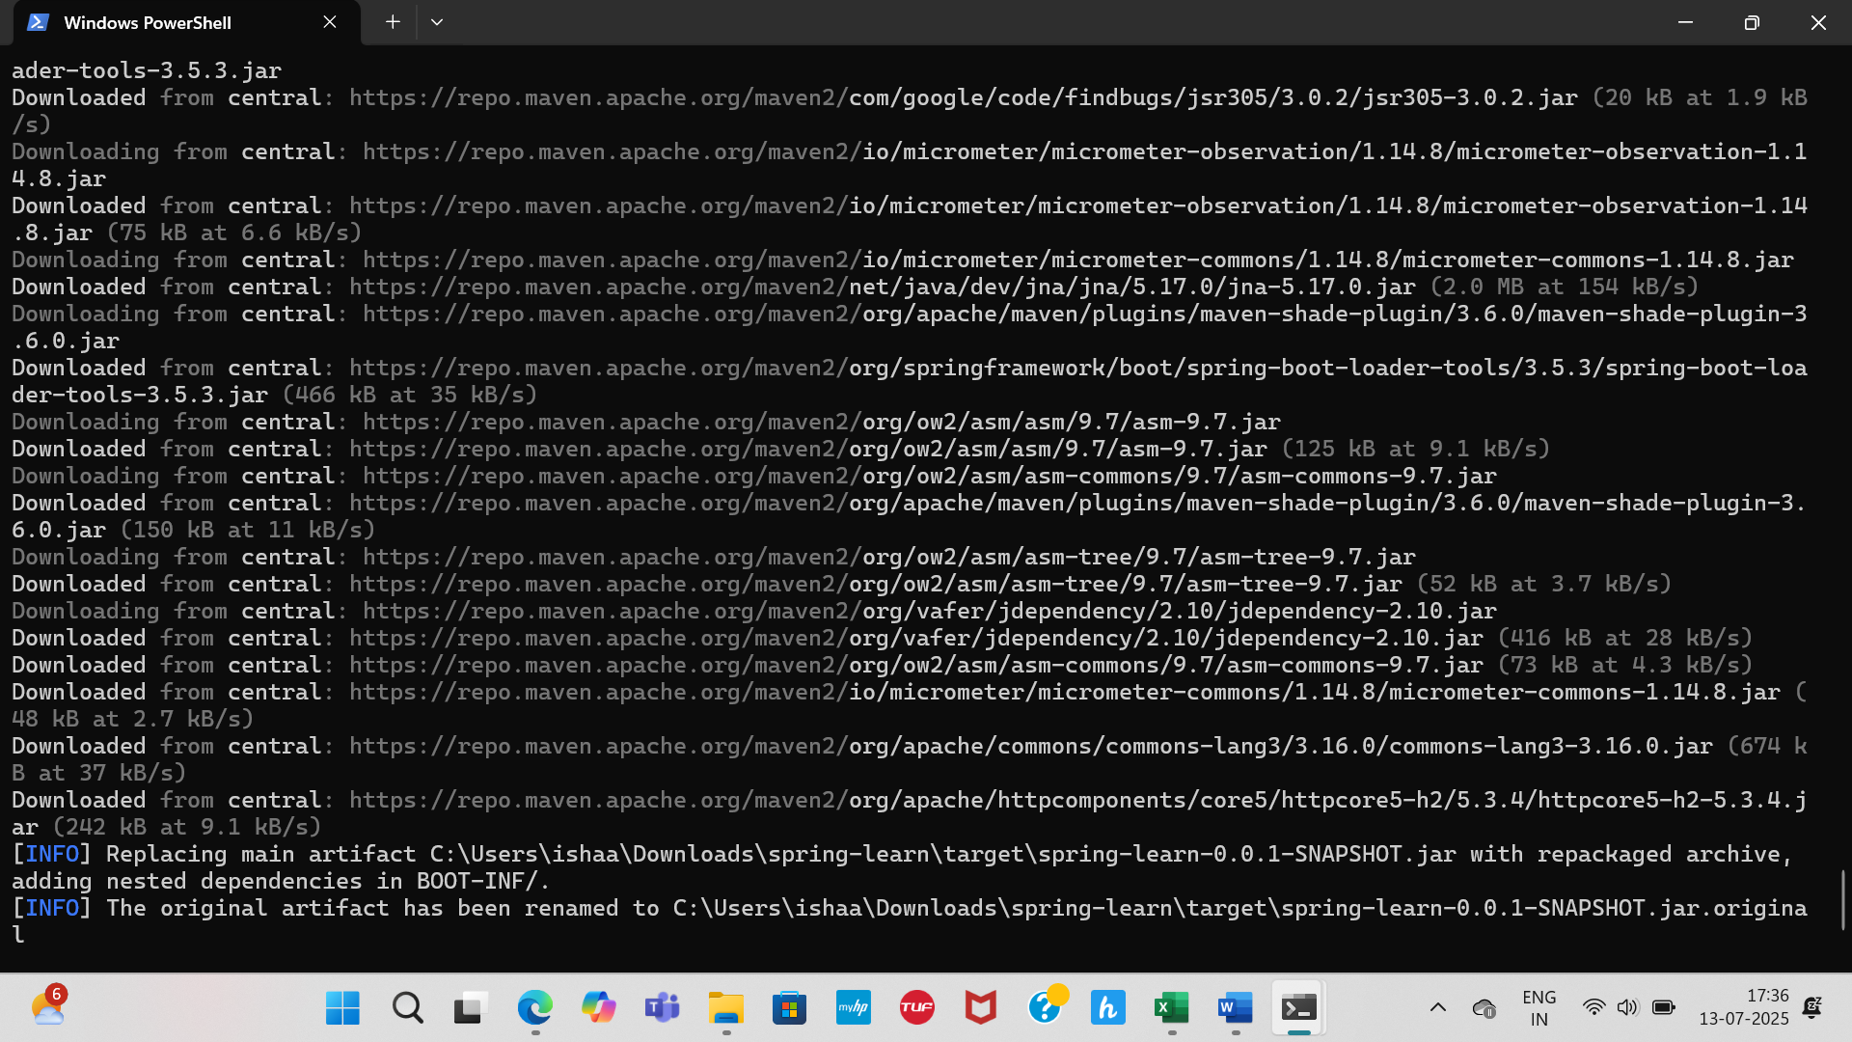

Task 2 – Included logs to verify main method and dependency tree

